Project Title: Bol-Bharat - Civic issue reporting platform
The Community Project Report
Submitted By:

Group Member Names | PRN Number
Kartik Shirode | EN24101115
Manasi Shivarkar | EN24101116
Silky Shahare | EN24101117
Kaveri Sonawane | EN24101118

Submitted in partial fulfilment of the requirements
for the Second Year Community Engineering Project
Computer Engineering
Under The Guidance of
Prof. Sushma Nandgaonkar


DEPARTMENT OF COMPUTER ENGINEERING

VIDYA PRATISTHANS KAMALNAYAN BAJAJ INSTITUTE
OF ENGINEERING AND TECHNOLOGY
BARAMATI- 431605 (M.S) INDIA
ACADEMIC YEAR: 2025-2026


VIDYA PRATISTHANS KAMALNAYAN BAJAJ INSTITUTE OF ENGINEERING AND TECHNOLOGY, BARAMATI-413133
DEPARTMENT OF COMPUTER ENGINEERING
CERTIFICATE
This is to certify that following Students
Group Member Names | PRN Number
Kartik Shirode | EN24101115
Manasi Shivarkar | EN24101116
Silky Shahare | EN24101117
Kaveri Sonawane | EN24101118

Has Successfully Completed His/Her Project Work On
Website BOL BHARAT- Civic Issue Reporting
https://bol-bharat-lac.vercel.app/

During The Academic Year 2025-2026 In The Partial Fulfillment Towards
The Completion of Community Engineering Project in Computer Engineering

Guide Project Coordinator Head of Department
Asst.Prof.Sushma Nandgaonkar Asst.Prof.Sushma Nandgaonkar Dr. A. M. Jagtap

Acknowledgments

We would like to express our deepest gratitude to our project guide, Prof. Sushma Nandgaonkar, for her invaluable guidance, unwavering support, and constant encouragement throughout the course of this project.
Her expert advice, insightful suggestions, and constructive feedback played a crucial role in shaping the development and successful completion of our work.
Her patience and dedication inspired us to approach challenges with confidence and determination.
We are also profoundly thankful to Prof. Sushma Nandgaonkar for continuous support and assistance during the project. The guidance and timely suggestions helped us navigate technical difficulties and improve the quality of our work.
We extend our heartfelt thanks to Dr. A. M. Jagtap, Head of the Department of Computer Engineering, for providing us with the necessary resources, infrastructure, and opportunities to undertake this community-based project.
The facilities and encouragement from the department greatly facilitated our learning experience and practical understanding.
Finally, we would like to convey our sincere gratitude to our friends whose constant encouragement, moral support, and motivation have been our backbone throughout this journey. Their patience and understanding allowed us to dedicate our time and efforts fully to this project.

Abstract

In India, citizens encounter substantial obstacles when attempting to report civic issues such as potholes, water leakage, garbage accumulation, and streetlight failures to the relevant government departments. The existing systems are fragmented across multiple platforms, lack transparency in complaint handling and resolution, and rely heavily on manual processes that often lead to delays and inefficiencies. These challenges create frustration among citizens and hinder effective civic participation.
BOL BHARAT (Speak Up, India!) is an innovative Al-powered civic issue reporting platform designed to empower citizens by enabling them to report issues seamlessly with photographic evidence and precise location data. The system leverages advanced Gemini Al technology alongside locally developed Machine Learning algorithms to automatically categorize complaints and intelligently route them to the correct government department based on the citizen's Pin code, eliminating the need for users to navigate complex administrative hierarchies.
The platform incorporates several key features that enhance user experience and civic engagement.
Real-time tracking capabilities powered by Firebase enable citizens to monitor the status of their complaints from submission through resolution. Community engagement is fostered through an upvoting mechanism that allows citizens to highlight widespread issues affecting their neighbourhoods, helping prioritize problems that impact larger populations. Additionally, the mobile-responsive design ensures accessibility across devices, allowing citizens to report issues conveniently whether they're using smartphones, tablets, or desktop computers, thereby promoting broader civic participation and accountability in governance.

Contents

Acknowledgments | i
Abstract | ii
List of Figures | v
1 Introduction | 1
1.1 Motivation | 1
1.2 Problem Definition | 1
1.3 Project Objective | 1
2 Literature Review | 2
3 Background | 3
3.1 Tech-1 | 3
3.2 Tech-2 | 3
4 System Requirements | 4
4.1 Software Requirements | 4
4.2 Hardware Requirements | 4
5 System Design | 5
5.1 System Architecture | 5
5.2 ER Diagram | 5
5.3 Activity Diagram | 5
5.4 User Sequence Diagram | 5
5.5 Data Flow Diagram | 5
6 System Implementation | 6
7 System Testing | 7
8 Experimental Results | 8
9 Conclusion | 9
10 Future Scope | 10
11 Contribution | 11
12 Abbreviations | 12
13 Bibliography | 13

List of Figures

Figure No. | Title
Figure 1 | User Flow for Citizen Complaint Registration
Figure 5.1 | System Architecture
Figure 5.2 | ER Diagram
Figure 5.3 | Activity Diagram
Figure 5.4 | User Sequence Diagram
Figure 5.5 | Data Flow Diagram (DFD)

Introduction
1.0 Background
India’s rapid urbanization has significantly increased the frequency of civic issues such as potholes, waste accumulation, water leakage, and infrastructure failures. As cities expand and populations grow, municipal bodies face increasing pressure to manage and resolve these problems efficiently. Traditional complaint systems-such as visiting offices, making phone calls, or using fragmented online portals-are often inconvenient, time-consuming, and inconsistent. Even existing digital platforms are usually limited in functionality, lack standardization across regions, and fail to provide a seamless user experience, leading to underreporting of issues and delayed resolutions.
With the rise of digital transformation initiatives and widespread smartphone usage, there is a strong opportunity to modernize civic engagement. Technologies like web-based systems and Artificial Intelligence can streamline complaint handling by enabling automated categorization, intelligent routing, and real-time tracking. However, there is still a lack of a unified, intelligent platform that integrates these capabilities effectively. This creates the need for a centralized solution like BOL BHARAT, which aims to simplify issue reporting, improve transparency, and strengthen communication between citizens and government authorities.

1.1 Motivation
In India, citizens often face difficulties in reporting civic issues such as potholes, garbage accumulation, water leakage, and streetlight failures. The existing systems are scattered across different platforms and involve manual processes, leading to delays, inefficiencies, and lack of transparency.
With the advancement of digital technologies and Artificial Intelligence, there is a strong opportunity to improve civic engagement and governance. By developing an integrated platform like BOL BHARAT, citizens can easily report issues, track their status, and ensure faster resolution.

1.2 Problem Definition
Citizens face several challenges while reporting civic issues:
- Lack of a centralized platform for complaint submission
- Difficulty in identifying the correct government department
- Manual processing leading to delays in issue resolution
- No proper tracking system or status updates
- Limited communication between citizens and authorities
These problems result in inefficiency, frustration, and reduced trust in public services.

1.3 Project Objectives
- To develop a user-friendly web-based platform for reporting civic issues easily.
- To use AI/ML techniques to automatically categorize complaints.
- To route complaints to the appropriate government department based on Pin code.
- To provide real-time tracking and status updates for submitted complaints.
- To enhance transparency, efficiency, and citizen participation through a centralized system.

Literature Review

2.1 Pre-requisite Information
To develop a civic issue reporting system like BOL BHARAT, it is important to understand the existing challenges in public grievance systems. Traditional methods rely on manual complaint submission or multiple disconnected platforms, which are inefficient and time-consuming.
With the use of modern technologies such as web development, cloud computing, and Artificial Intelligence (AI), it is possible to build an integrated platform. This system can automate complaint registration, classification, and routing while ensuring transparency and efficient communication between citizens and government authorities.

2.2 Understanding Civic Issue Reporting Systems
Civic issue reporting systems are digital platforms that allow citizens to report public problems such as potholes, garbage, water leakage, and streetlight failures. These systems help authorities manage complaints efficiently and improve public services.
An effective system should provide easy complaint submission, proper categorization, quick forwarding to the correct department, and real-time status tracking.

2.3 Web and AI Technologies
The BOL BHARAT system uses:
- Frontend: HTML, CSS, JavaScript for a responsive user interface
- Backend: Node.js / Firebase for handling server-side operations
- Database: Firebase Realtime Database / Firestore for storing complaint data
- AI Tools: Gemini AI / Machine Learning models for automatic classification
- Hosting: Firebase / Cloud platform
The system is designed to be mobile-friendly for easy access by all users.

2.4 User Roles and System Workflow
User Roles:
- Citizen: Register/login, report issues, upload images, track complaints, upvote issues
- Government Authority/Admin: View complaints, verify details, take action, update status
- System (AI Module): Classify issues and route to the correct department
Workflow:
- Register/Login
- Submit complaint (image + location + description)
- AI categorizes issue
- Complaint routed using Pin code
- Authority takes action
- Status updated and user notified

2.5 Existing Solutions and Gaps
Many existing civic platforms have limitations:
- Lack of centralized system for all civic issues
- Manual categorization and routing
- No real-time tracking or updates
- Limited user engagement features
- Poor mobile accessibility
Gap:
There is a need for an integrated, AI-based, and user-friendly platform that provides automated classification, smart routing, real-time tracking, and community participation.
BOL BHARAT addresses these gaps effectively.

2.6 Skills and Tools Required
Skills:
- Web Development (Frontend & Backend)
- Database Management
- Artificial Intelligence / Machine Learning
- UI/UX Design
Tools:
- VS Code
- Firebase / Cloud services
- Figma or Canva (for UI design)
- APIs for location and notifications

Background

3.1 Frontend Development (Tech-1: HTML-CSS-JS)
Information:
Frontend development is responsible for creating the visual and interactive interface of the BOL BHARAT system. Using HTML, CSS, and JavaScript, the platform provides a simple, user-friendly, and responsive design. HTML structures the pages, CSS enhances the appearance, and JavaScript enables interactivity such as form validation, image upload, and dynamic updates.
Usage in Project:
- Designing user interface for complaint submission and tracking
- Enabling image upload and location input features
- Providing responsive design for mobile and desktop users
- Displaying real-time complaint status updates

3.2 Backend Development (Tech-2: Node.js / Firebase)
Information:
Backend development handles server-side operations, business logic, and communication between frontend and database. Technologies like Node.js or Firebase are used to process user requests, manage authentication, and ensure smooth system functioning.
Usage in Project:
- Managing user registration, login, and authentication
- Processing complaint data submitted by users
- Integrating AI module for automatic issue classification
- Routing complaints to appropriate departments based on Pin code
- Handling notifications and real-time updates
3.3 Database ( Firebase / Cloud Database)
Information:
The database acts as the core of the system, storing all important information such as user details, complaints, images, and status updates. Firebase provides real-time data synchronization and scalability, ensuring fast and reliable data access.
Usage in Project:
- Storing user profiles and complaint details
- Managing complaint status and history
- Storing uploaded images and location data
- Providing real-time updates for tracking complaints
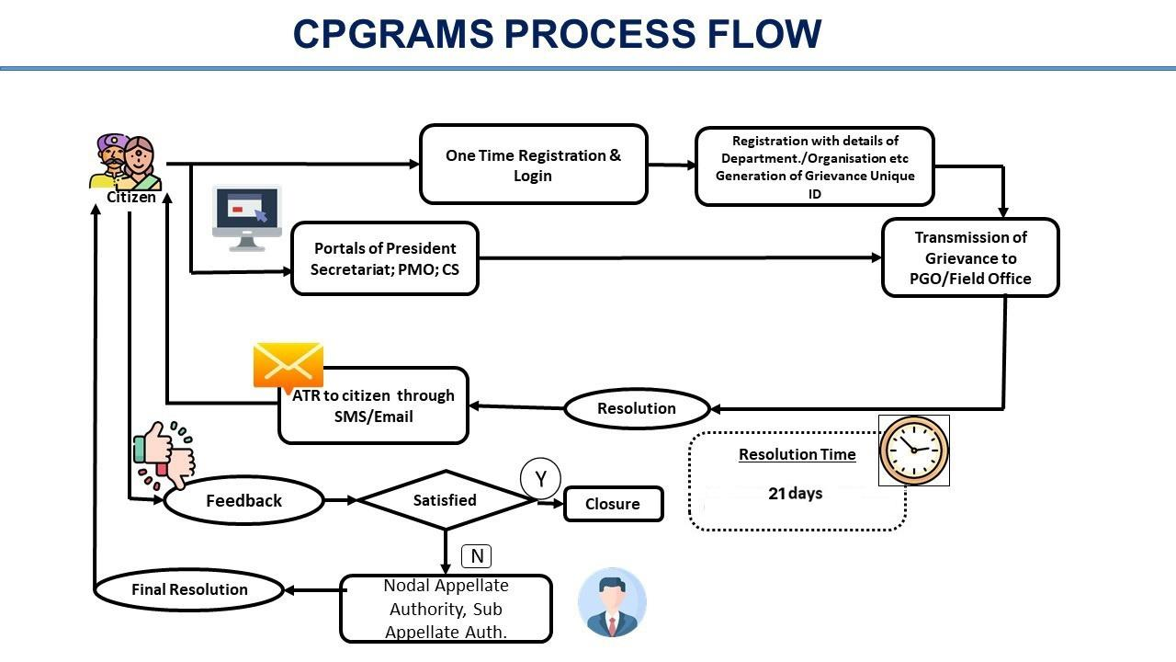
Figure 1: User Flow for Citizen Complaint Registration

System Requirements

4.1 Software Requirements
- Operating System:
Windows 10, Linux, or macOS -used to develop and run the application smoothly.
- Web Browser:
Google Chrome, Mozilla Firefox, or Microsoft Edge -used for testing and accessing the website.
- Frontend Technology:
HTML, CSS, and JavaScript -used to create a simple, attractive, and user-friendly interface for reporting and tracking complaints.
- Backend Technology:
Node.js / Firebase -used to handle data processing, user requests, and system logic in the background.
- Database:
Firebase / Cloud Database -used to store user details, complaints, images, and status updates securely.
- Development Environment:
Visual Studio Code -used for writing and managing the project code easily.
- Version Control:
Git and GitHub -used to save code, track changes, and work in a team efficiently.
- API Testing Tool:
Postman -used to test backend APIs and make sure the system works properly.
4.2 Hardware Requirements
Development Environment
- Processor: Intel Core i5 / AMD Ryzen 5 (or equivalent)
- RAM: 8 GB (16 GB recommended)
- Storage: 256 GB SSD
- Operating System: Windows 10/11, macOS 11+, or Ubuntu 20.04+
- Internet Connection: Broadband (required for Firebase & Gemini API)
End-User Device (Citizen)
- Device Type: Smartphone (Android 8+, iOS 13+) or Desktop
- RAM: Minimum 2 GB
- Camera: Rear camera (for photo upload)
- Internet: 3G/4G mobile data or Wi-Fi
- Browser: Any modern mobile browser (Chrome, Safari)
System Design

5.1 System Architecture

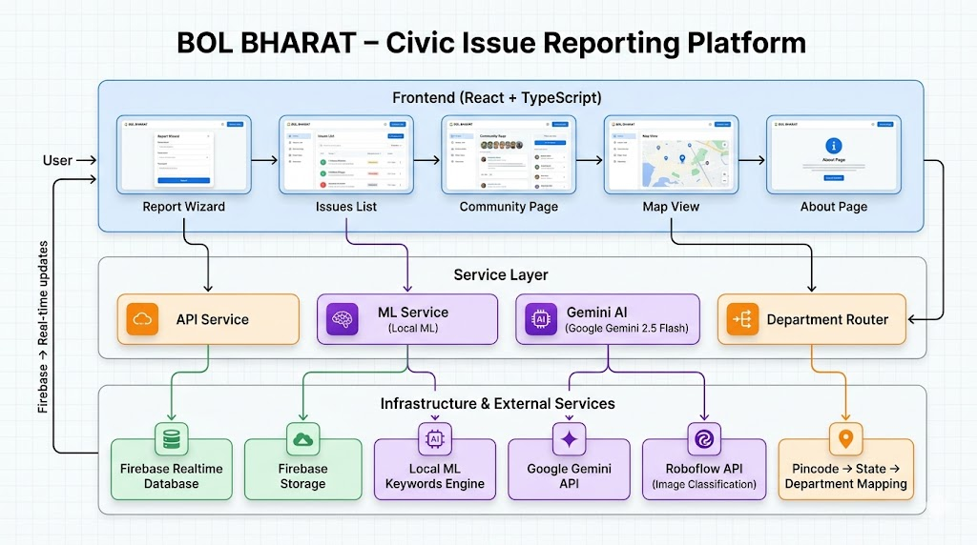

5.2 ER Diagram

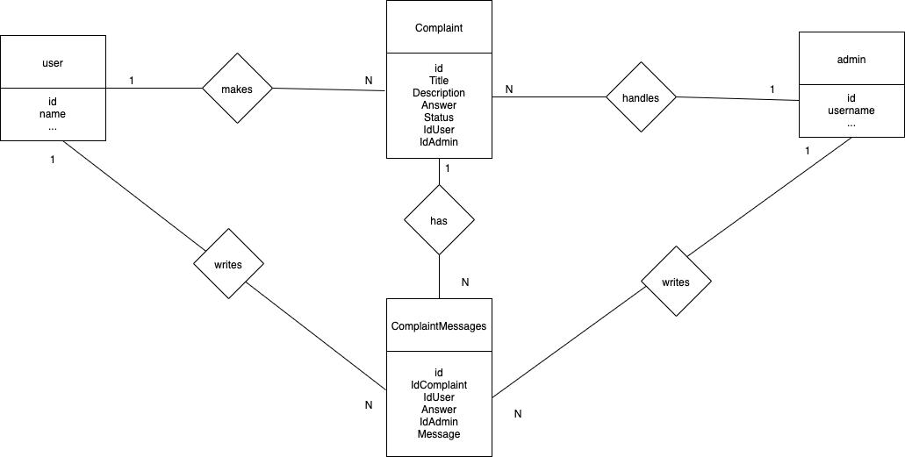

5.3 Activity Diagram

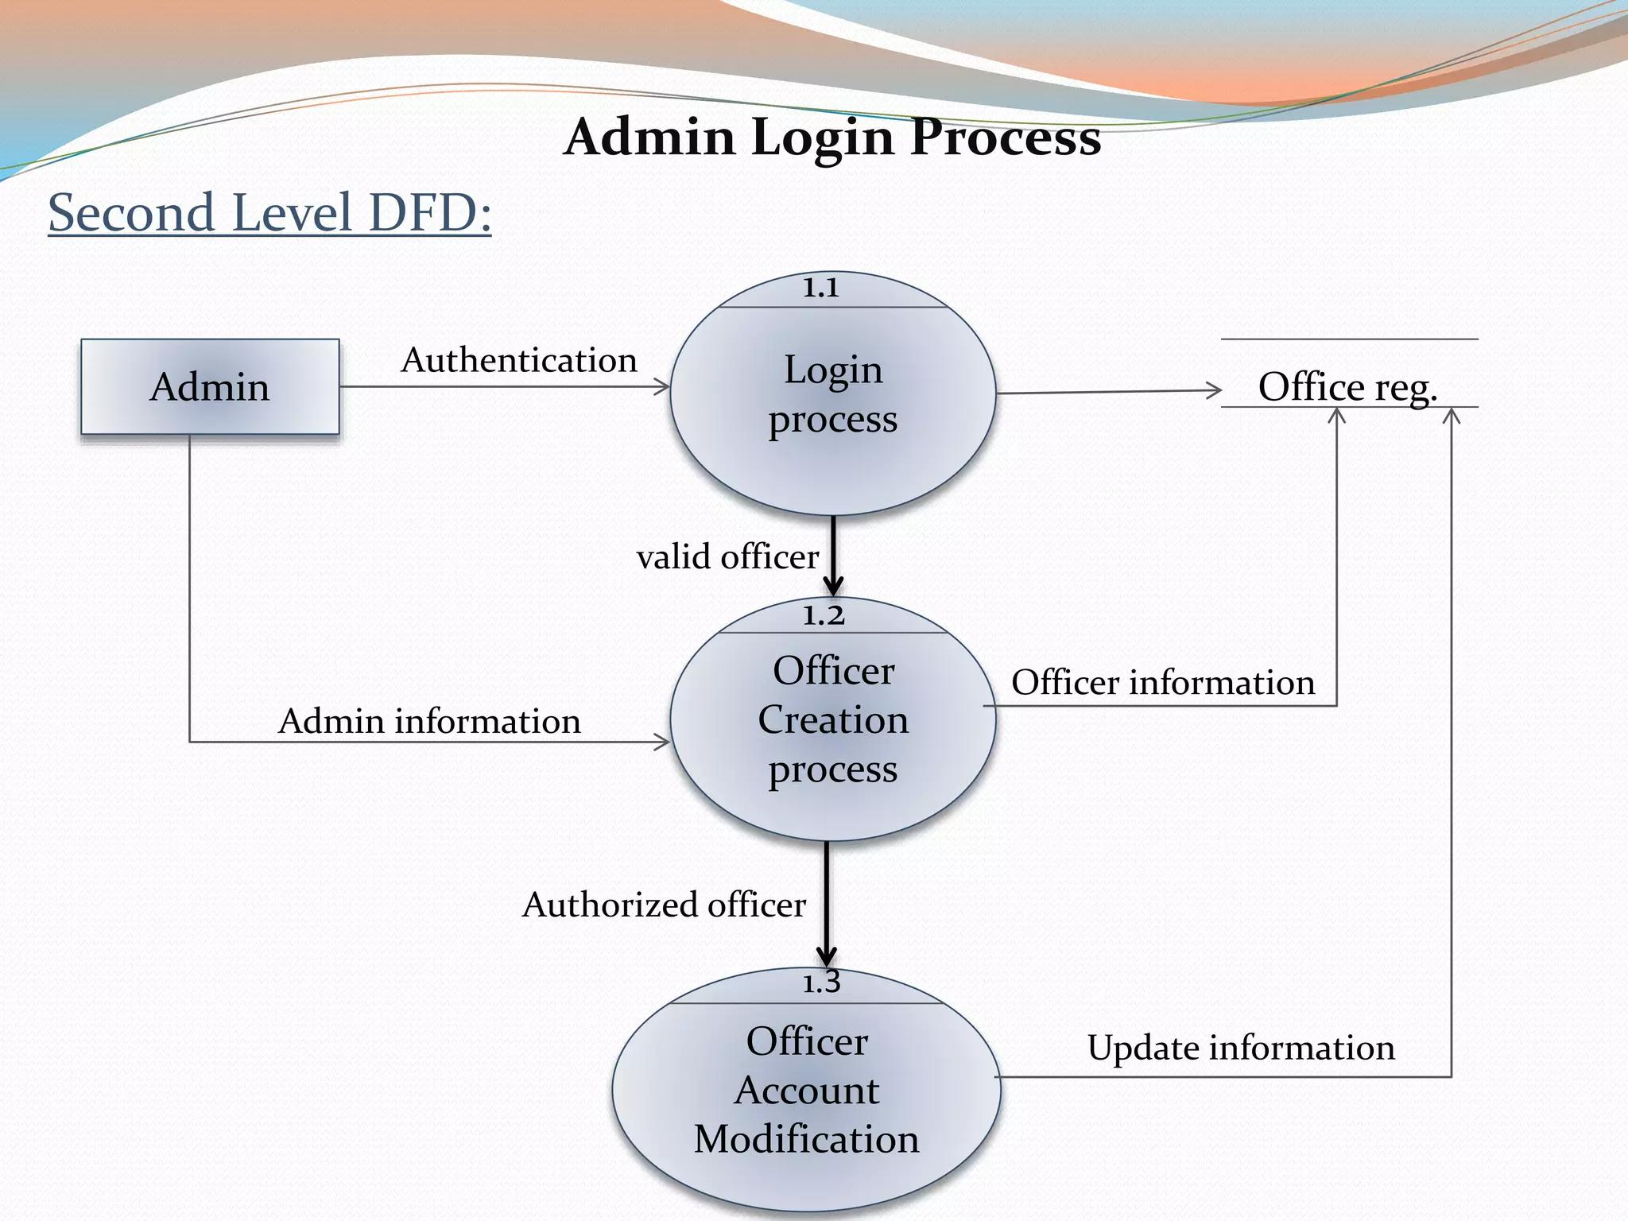

5.4 User Sequence Diagram

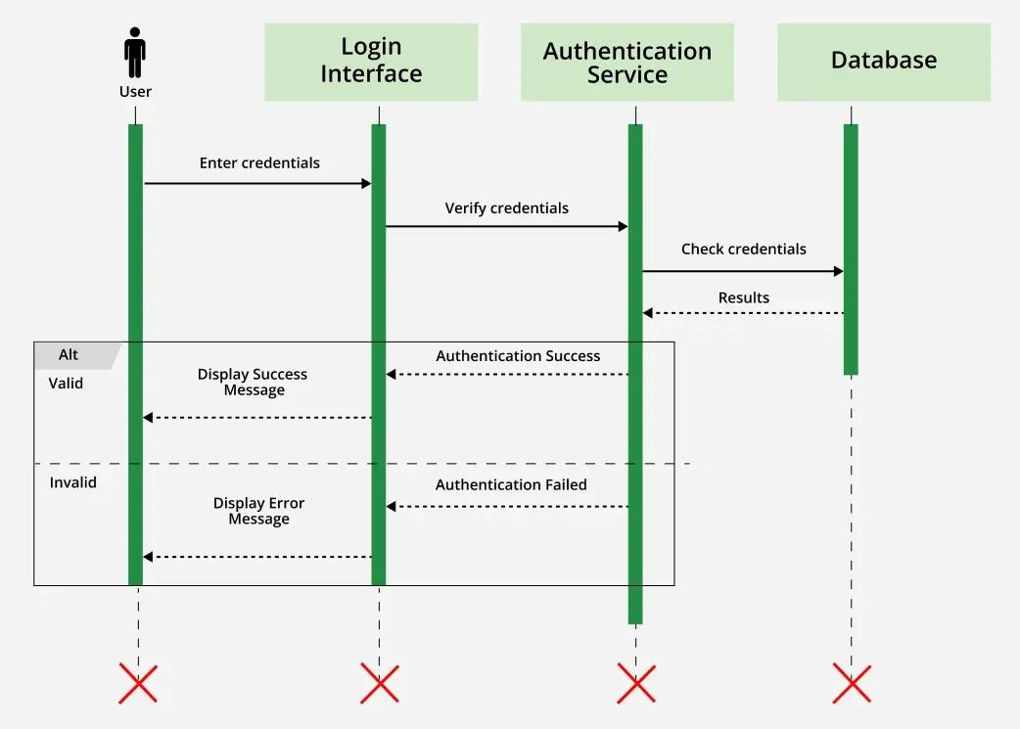

5.5 Data Flow Diagram (DFD)

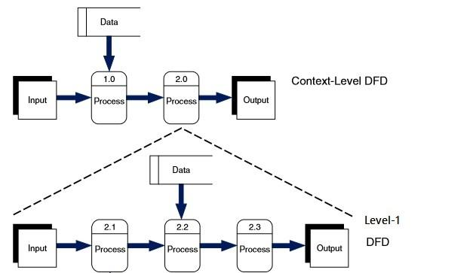

System Implementation

The BOL BHARAT system is a web-based platform that helps people report civic problems easily and connects them with government authorities. It works in three main parts: frontend, backend, and database.

1. Overview
- Frontend:
This is the part that users see and use. It is made using HTML, CSS, and JavaScript. People can register, log in, upload complaints with photos and location, and check the status of their complaints. Authorities can also view and manage complaints from here.
- Backend:
This works behind the scenes. It handles things like login, saving complaints, and sending them to the correct department. It also uses AI to understand what type of problem it is (like pothole, garbage, etc.).
- Database:
This is where all the information is stored safely. It keeps user details, complaints, images, and updates. It also helps show real-time status to users.

2. Technologies Used
- Frontend:
HTML, CSS, JavaScript -used to design simple and easy-to-use pages
- Backend:
Node.js / Firebase -used to manage data and system operations
- Database:
Firebase -used to store all data and provide live updates
- Other Tools:
AI (Gemini) -to automatically identify the type of issue
Postman -to test the system
VS Code -to write and manage code
REST APIs -to connect frontend and backend

3. Implementation Summary
The development of BOL BHARAT started by setting up the coding environment and creating the basic structure using HTML, CSS, and JavaScript for the frontend and Node.js/Firebase for the backend. The project was developed step-by-step by dividing it into different modules:
- Citizen Module:
Registration, login, submitting complaints (with image and location), tracking complaint status, and upvoting issues.
- Authority/Admin Module:
Viewing complaints, verifying details, taking action, and updating status (Pending/In Progress/Resolved).
- AI Module:
Automatically identifies the type of issue (like pothole, garbage, etc.) and helps in quick processing.
- Data Management:
All user data, complaints, images, and status updates are stored securely in the database.
APIs were used to connect the frontend with the backend. Each module was tested separately and then combined to make sure the system works smoothly.

4. Deployment
The BOL BHARAT system can be deployed easily using cloud platforms:
- Frontend:
Hosted on platforms like Vercel or Netlify for fast access
- Backend & Database:
Hosted on Firebase or cloud services like Render
This setup makes the system available from anywhere and ensures good performance, security, and scalability.

System Testing

1. Objective
The main goal of testing is to make sure that all parts of the BOL BHARAT system work properly together. It checks whether users can report issues, track them, and receive updates without any problems.

2. Types of Testing Performed
- Unit Testing:
Each feature like login, complaint submission, and tracking was tested separately.
- Integration Testing:
Checked whether frontend, backend, and database work together correctly.
- System Testing:
Tested the complete system in real-life situations.
- User Acceptance Testing (UAT):
Tested by users to make sure the system is easy to use and works as expected.

3. Test Scenarios
- Successful and failed login attempts
- Submitting complaints with image and location
- Checking complaint status updates
- Verifying database storage
- Testing on mobile devices and slow internet
- Checking invalid inputs (empty or wrong data)

4. Test Results
All modules of BOL BHARAT worked correctly. Complaints were stored properly, AI classified them accurately, and status updates were shown to users in real-time. The system performed well on different devices and conditions.

5. Conclusion
The BOL BHARAT system was successfully tested and found to be reliable, easy to use, and efficient. All main features like complaint submission, AI classification, routing, and tracking worked properly. The system meets the needs of citizens and helps improve communication with government authorities.

Experimental Results

The BOL BHARAT system was tested in different situations to check its performance, reliability, and ease of use. The system successfully performed all its main functions, such as complaint submission, AI-based classification, routing to the correct department, and status tracking.
During testing, all parts of the system worked properly, and data was transferred correctly between the frontend and backend. The application responded quickly and provided a smooth and user-friendly experience.
The results showed that the system:
- Allows citizens to easily register, log in, and report civic issues with images and location
- Automatically classifies complaints using AI, reducing manual work
- Sends complaints to the correct government department based on Pin code
- Enables authorities to manage and update complaint status efficiently
- Provides real-time tracking and notifications to users
- Stores all data securely and accurately in the database

Conclusion

The BOL BHARAT system was developed to make it easy for citizens to report civic issues and connect directly with government authorities through a single digital platform. By reducing manual processes and improving communication, the system increases efficiency, transparency, and public participation.

Modern technologies like HTML, CSS, JavaScript, Node.js/Firebase, and AI (Gemini) were used to build a simple, secure, and user-friendly application. Important features such as complaint submission with images and location, AI-based classification, automatic routing to the correct department, and real-time status tracking were successfully implemented and tested.

The system is designed to work smoothly on mobile devices, making it easy for users to report issues anytime and from anywhere. Real-time updates and notifications keep users informed about the progress of their complaints.

In conclusion, BOL BHARAT is an effective and reliable solution that helps improve civic issue management, reduces delays, and encourages active participation from citizens, ultimately supporting better governance and smarter cities.

Future Scope

The BOL BHARAT system has great potential for future improvements as technology and digital usage continue to grow. More advanced features can be added to make the system more useful, efficient, and user-friendly:
- Develop a mobile application (Android & iOS) for easier access
- Add multilingual support so users can report issues in their local language
- Improve AI accuracy for better classification and faster processing of complaints
- Integrate with government systems for faster response and direct action
- Provide real-time notifications through SMS, email, or app alerts
- Add GPS-based location tracking for more accurate complaint reporting
- Include analytics and reports to identify common issues in specific areas
- Strengthen security and user authentication for safe data handling
These improvements will make BOL BHARAT more powerful, scalable, and helpful in solving civic issues and improving communication between citizens and authorities.

Contribution

Sr. No. | Member Name | Technical Contribution | Non-technical Contribution
1 | Kartik Shirode | Led system development; built Firebase backend; integrated Gemini Vision API; routing engine | Coordinated team tasks; managed GitHub; guided technical decisions
2 | Manasi Shivarkar | Developed frontend using React.js; complaint form; tracking dashboard; upvoting system | Created demo video; handled social media; managed marketing and outreach
3 | Silky Shahare | Implemented Firebase Authentication; Cloud Storage; official dashboard | Designed poster; prepared report; contributed to presentation slides
4 | Kaveri Sonawane | Google Maps integration; GPS pin code detection; responsive UI using Tailwind CSS | Managed copyright documentation; ensured attribution; compiled bibliography

Abbreviations
- AI – Artificial Intelligence A branch of computer science that enables machines to simulate human intelligence, including learning, reasoning, and decision-making. Used in BOL BHARAT for automatic complaint classification via the Gemini Vision API.
- API – Application Programming Interface A set of rules and protocols that enables communication between different software applications, allowing data exchange between the frontend and backend. Used to integrate Gemini AI, Google Maps, and Firebase services.
- CSS – Cascading Style Sheets Used to style and format HTML content, controlling layout, colors, fonts, and overall appearance. Used in BOL BHARAT for mobile-responsive UI design via Tailwind CSS.
- DFD – Data Flow Diagram A visual representation that shows how data moves through a system, illustrating the flow of information between processes, data stores, and external entities.
- ER – Entity Relationship A modeling technique used to represent the structure of a database, showing entities (like Users, Complaints, Departments) and their relationships with one another.
- GPS – Global Positioning System A satellite-based navigation system that provides real-time geographic location and time information. Used in BOL BHARAT to automatically detect the citizen's location during complaint submission.
- HTTP – HyperText Transfer Protocol The protocol used for communication between a web client (browser) and a server, defining how messages are formatted and transmitted. Used for all API calls between the frontend and Firebase/Gemini services.
- JS – JavaScript A programming language that adds interactivity to web pages, including dynamic content, animations, and form validation. Used extensively in BOL BHARAT through the React.js framework.
- JSON – JavaScript Object Notation A lightweight data format used for storing and exchanging data between a server and a web application. Used for API request and response payloads throughout the system.
- ML – Machine Learning A subset of AI that enables systems to learn and improve from data without being explicitly programmed. Used in BOL BHARAT as a local fallback classifier for complaint categorization.
- NoSQL – Not Only SQL A category of database management systems that store data in flexible, non-tabular formats such as documents or key-value pairs. Firebase Firestore, the database used in BOL BHARAT, is a NoSQL database.
- PWA – Progressive Web Application A type of web application that delivers an app-like experience on mobile devices, supporting features like home screen installation and offline access. BOL BHARAT is designed to be PWA-compatible.
- SDK – Software Development Kit A collection of tools, libraries, and documentation that developers use to build applications for a specific platform. Firebase SDK is used in BOL BHARAT to integrate all Firebase services.
- SPA – Single Page Application A web application that loads a single HTML page and dynamically updates content without full page reloads, providing a faster and smoother user experience. BOL BHARAT is built as an SPA using React.js.
- UI – User Interface The visual elements through which a user interacts with a software application, including buttons, forms, menus, and layouts. BOL BHARAT's UI is designed to be simple and mobile-friendly.
- URL – Uniform Resource Locator The web address used to access resources on the internet. Used in BOL BHARAT to reference uploaded complaint photos stored in Firebase Cloud Storage.
- UX – User Experience The overall experience a user has while interacting with a system, encompassing ease of use, accessibility, and satisfaction. BOL BHARAT prioritizes UX through intuitive design and real-time feedback.

Bibliography
Books:
- Google DeepMind. (2024). Gemini: A Family of Highly Capable Multimodal Models. Google LLC.
- Flanagan, D. (2020). JavaScript: The Definitive Guide. O'Reilly Media.
- Duckett, J. (2014). HTML & CSS: Design and Build Websites. Wiley.
- Connolly, T., & Begg, C. (2015). Database Systems: A Practical Approach to Design, Implementation, and Management. Pearson.
- Sommerville, I. (2016). Software Engineering. Pearson.
Research Papers / Journals:
- Maeda, H., Sekimoto, Y., Seto, T., Kashiyama, T., & Omata, H. (2018). "Road Damage Detection and Classification Using Deep Neural Networks with Smartphone Images." Computer-Aided Civil and Infrastructure Engineering, 33(12), 1127–1141.
- Minkoff, S. L. (2016). "NYC 311: A Tract-Level Analysis of Citizen–Government Interaction in New York City." Urban Affairs Review, 52(2), 211–246.
- Singh, A., & Kumar, V. (2020). "AI-Based Complaint Classification for Smart City Governance." International Journal of Computer Applications, 9(2), 45–53.
- Reddy, P., & Rao, M. (2019). "Role of Web-Based Systems in Civic and Urban Management." Journal of Educational Technology, 38(4), 345–360.
Software / Tools References:
- Visual Studio Code. (n.d.). Code Editor. Microsoft. https://code.visualstudio.com
- Firebase. (n.d.). App Development Platform. Google LLC. https://firebase.google.com
- Gemini API. (n.d.). Multimodal AI API. Google DeepMind. https://ai.google.dev
- Tailwind CSS. (n.d.). Utility-First CSS Framework. https://tailwindcss.com
- GitHub. (n.d.). Version Control and Collaboration Platform. https://github.com
- Vercel. (n.d.). Frontend Cloud Deployment Platform. https://vercel.com

